Final glides
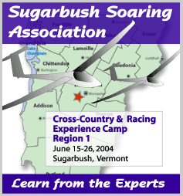
G Dale

In competition flying races are often won and lost on the starts and the final glides.

Theory
The time to leave the last thermal is when you can get there at the McReady speed appropriate to the current rate of climb. (Instead of a glide / climb unit you take a climb / glide unit)

So you set the vario / computer to the average climb you are getting ( you have to keep adjusting it) and enter the wind ( should be automatic ) and go when you have just enough height.

Practice
Many problems, some practical, some psychological.

Safety margin, arrival height and elevation of landing place.
Don’t get confused between the three.

You need to fly the final glide to the correct elevation of your airfield. Some computers will do this automatically – if the database is correct! Check, every time.

You need to arrive with enough energy to land safely. This is your arrival height and is dependent on the weather conditions, your competence and what type of finish you will fly at the arrival airfield.

You also need to use some kind of a safety margin. This varies according to circumstances and can be non existent in (easy terrain and still air ) or large (in difficult terrain, strong soaring conditions)
There will be a temptation to shave away the safety margin and the arrival height to save time. Don’t do it until you are very experienced, and even then with caution. It may be considered acceptable to risk the aircraft but it is not acceptable to risk your life – so if you are not prepared to trash the glider in an emergency field landing and walk away from the accident then keep your final glides high.
It is also a high risk strategy to use in a comp and completely inappropriate to any kind of distance flights (badges)

Psychology
We tend to consider “getting on final glide” as the end of the flight.
This causes inefficient flying on the glide itself and poor strategy regarding when to start the glide. (examples – trying to get on glide too early, trying to establish safety margin when not necessary, flying all of glide too fast through excessive safety margin)

When you are on the glide you should still fly dolphin style to increase the energy and avoid sink. (examples – blue streets)

A perfect final glide
This sometimes is the result of a good climb to around cloudbase – at the right distance for a glide to base at the speed appropriate to the last thermal. Very occasionally.
More usually you will find yourself reaching the correct angle closer in and not so high.
Sometimes you can “dolphin up” onto final glide – this is usually the fastest way to do it.

